**Create A Database In Cloudant DB**

To create a database in Cloudant DB to store location data

Steps:

1. Log in to IBM Cloud account

2. Click “Create Resource +” button

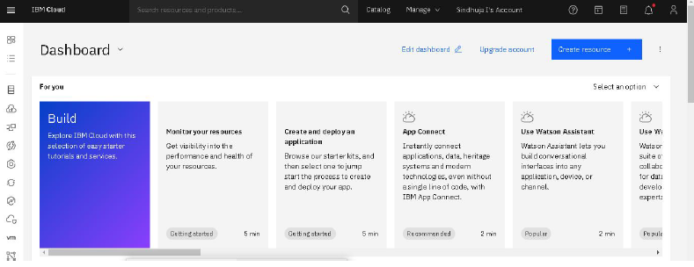

3. Search for Cloudant

4. Choose the Lite Version

5. Click on Create

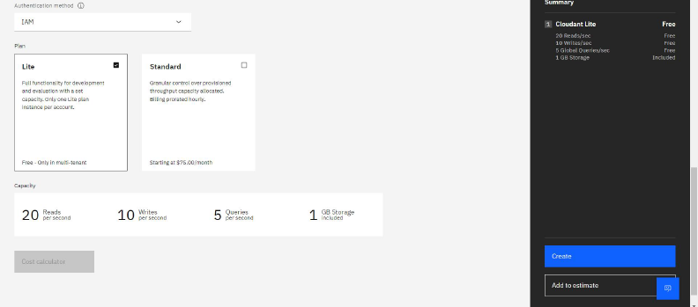

6.The Cloudant database resource created

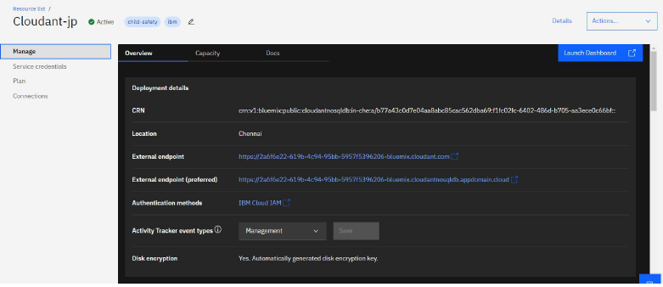

7.click on launch dashboard

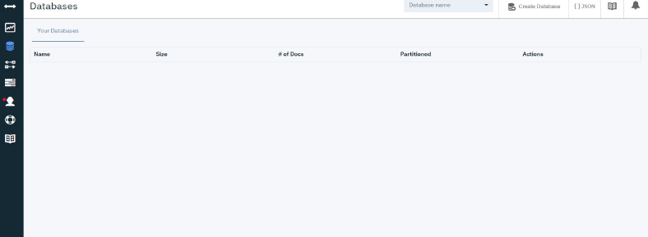

8.Click “Create Database”. Entered “sindhuja” as the database

name and the “Non-partitioned” option

9. The database “sindhuja” has been created.

**Conclusion:**

A database to store the location data on Cloudant DataBase has been created successfully.